The Upzoning Case: Working With Macros

The By-Right Scenario Pro-Forma Excel file for The Upzoning Case is a “Macro-enabled file”, meaning there is a “Macro”, or small computer program contained in the file that automates a series of actions when you initiate the Macro. Excel files that contain Macros have the file extension “.xlsm” as opposed to just “.xls”.

In this case, there are actually three Macros contained in the file.

Two of the Macros simply set the Print Area on the Assumptions Input tab to either be the left-hand page or the right-hand page. We have “attached” these two Macros to their respective gray buttons on the top of the tab.

The third Macro, attached to the square button near cell P43, adjusts the Senior Construction Loan size when the Uses of Funds (project costs) and Sources of Funds (project funding sources, of which the Construction loan is one) fall out of balance with one another. It does this by running the Goal Seek function to change the size of the Senior Loan in cell O34 until the check in cell P41 between Total Uses and Sources of Funds is equal to 0 (meaning they are equal to one another).

Macros are powerful and can be big time-savers, but they are inherently fragile, so you might need to “fix” the Adjust Senior Loan Macro if you make changes to the grid on the Assumptions Input tab in the course of doing the Upzoning analysis.

Instructions for launching the file properly, and an example issue and solution are included on the following pages.

To Launch The File Properly: When you launch the file, if prompted by Excel, be sure to click “Enable Content”. This enables the Macros to run.

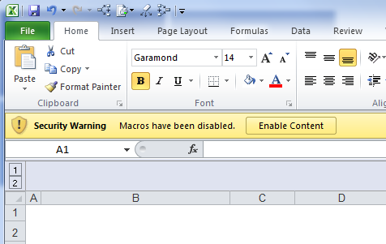

Example Problem and Solution:

Q: I added the extra costs in the Assumptions Input tab and had to fix the errors in the S & U tab and everything cleared "OK". I am now stuck at the Development Sources of Funds box on the Assumptions Input tab because I added a few extra rows - the Senior Loan Check is off/negative and the button to adjust the loan now has an error. How do I fix that?

A: FOLLOW THESE INSTRUCTIONS CAREFULLY

1. Close ALL other Excel files open on your computer
2. Click on the View tab in the Microsoft ribbon at the top
3. Click on Macros > View Macros

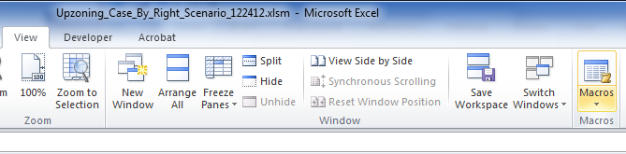

4. In the dialog box that has appeared, click on SeniorLoan_Adjust and then click the Edit button on the right sidebar of the dialog box

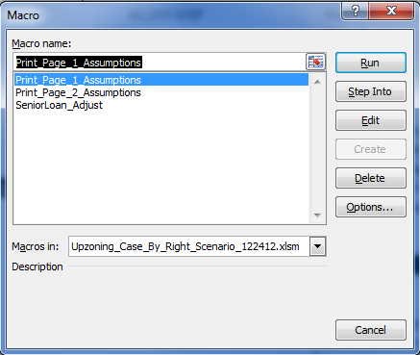

5. A crazy Microsoft Visual Basic for Applications screen will launch on top of your Excel file

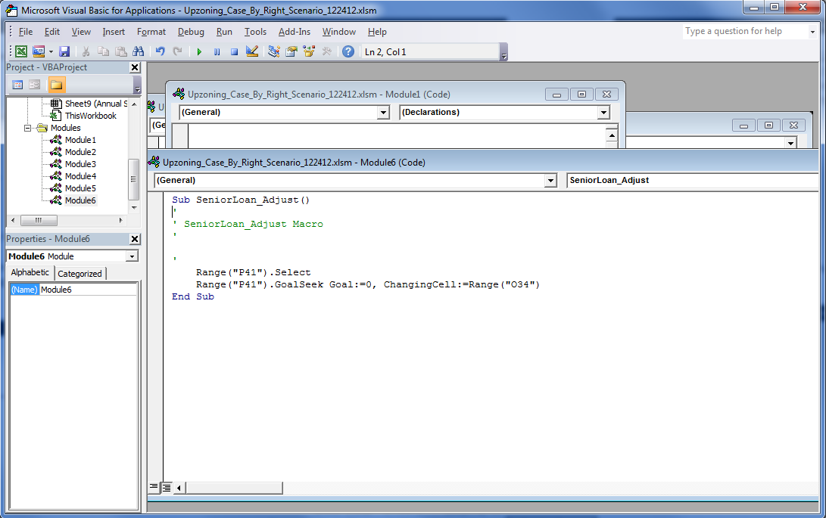

6. In the floating box on the right that says "Sub SeniorLoan_Adjust( )" in its top line, change the cell coordinates in the quotation marks to those cells that now apply given the new set of grid coordinates on your Assumptions Input tab. For instance, if your Senior Loan check amount (cell P41 in the original version of the model) is now P42, replace P41 with P42 (in both instances where it is referenced in the Visual Basic window)

Do the same for the Senior Loan amount (which was cell O34 in the original version of the model).

7. Click the Save icon in the Visual Basic window (the little floppy disk icon), or hit Ctrl+S

8. Then X out of the Visual Basic window in the top-right of the window.

9. Now click the Adjust Senior Loan button again and it should work fine.

